Name: Sanika Botre PRN: 25070122063
Batch: 2025-29 Branch: CSE A-2
Subject: Programming with Java

ASSIGNMENT No: 12

TITLE: Write a Java program to create and use user-defined packages.

Problem Statement: Write a Java program to create and use user-defined packages.

Learning Objectives: To create and use user-defined packages for organizing Java programs.

Theory: Packages are used to organize related classes and interfaces into namespaces. User-defined packages improve code organization, reduce naming conflicts, and enhance reusability. They also support access protection and modular application development. Java packages simplify project management by grouping logically related components together. Largescale software systems extensively use packages.

Questions:

1. Create a Java program by developing user-defined packages for a College Management System. Create separate packages for student and faculty details, and display their information using classes from these packages.
Code:
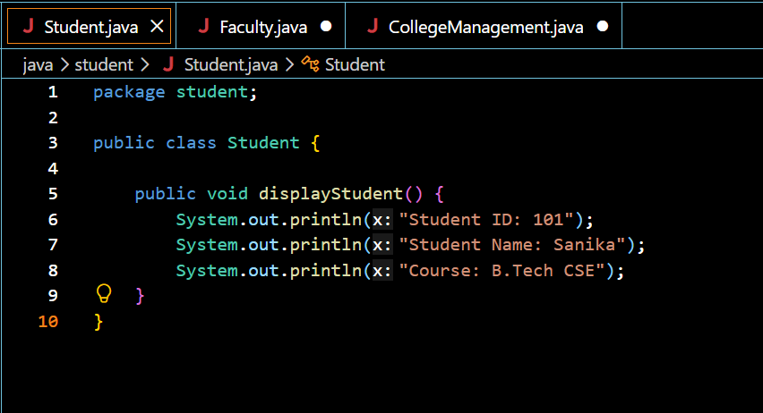
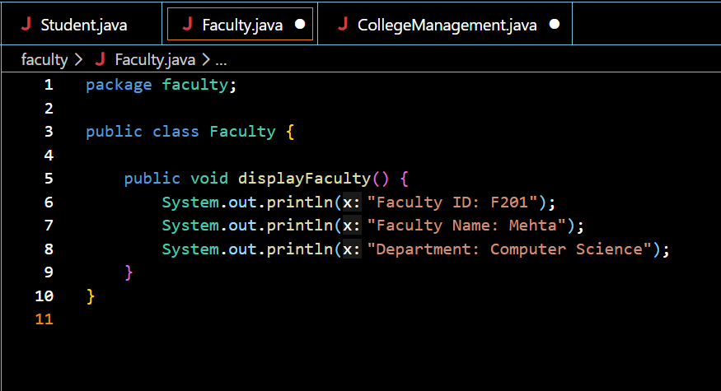
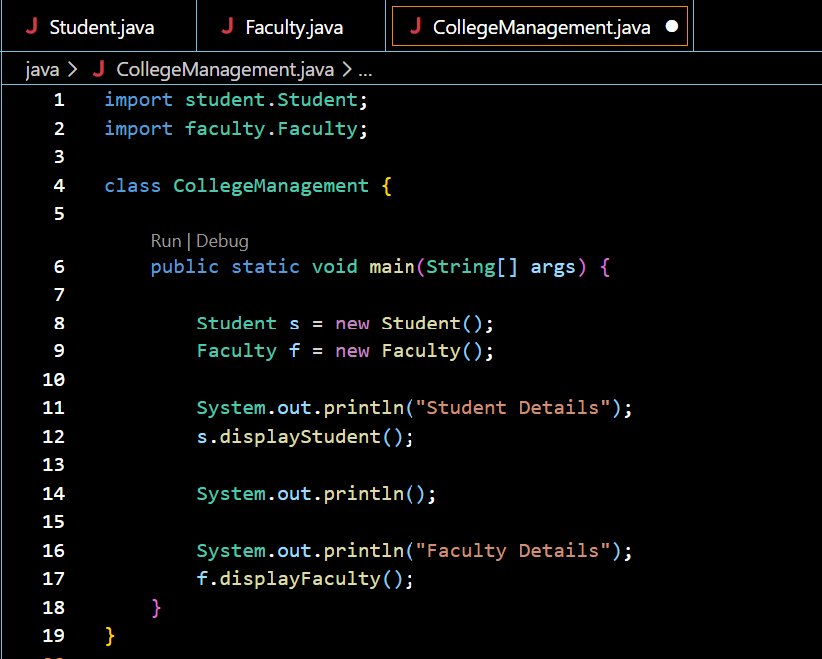

Output:
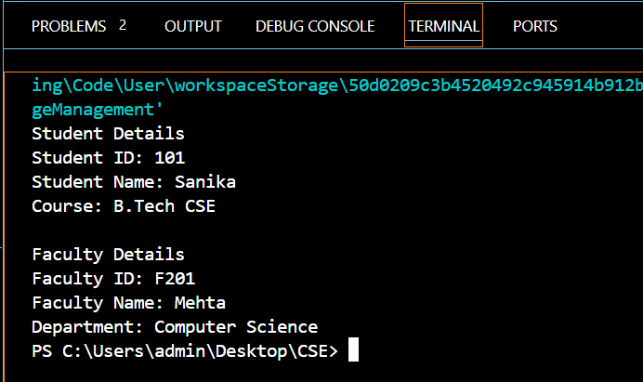

2. Create a Java program by developing a user-defined package named library that contains a class to store and display book details such as book ID, title, author, and price. Import the package into the main program and display the book information.
Code:
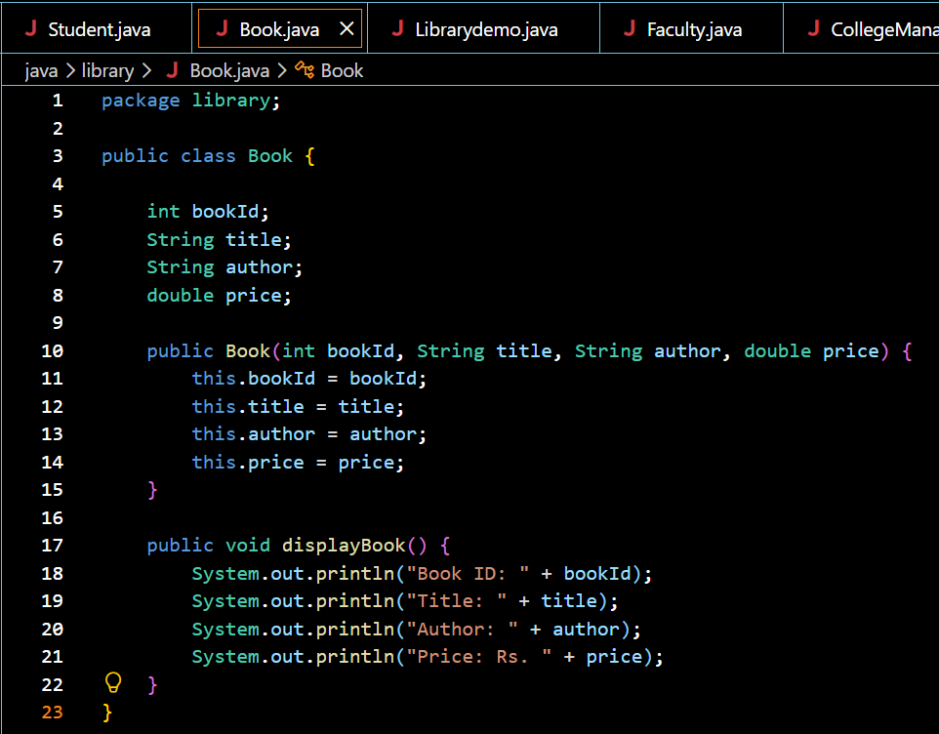
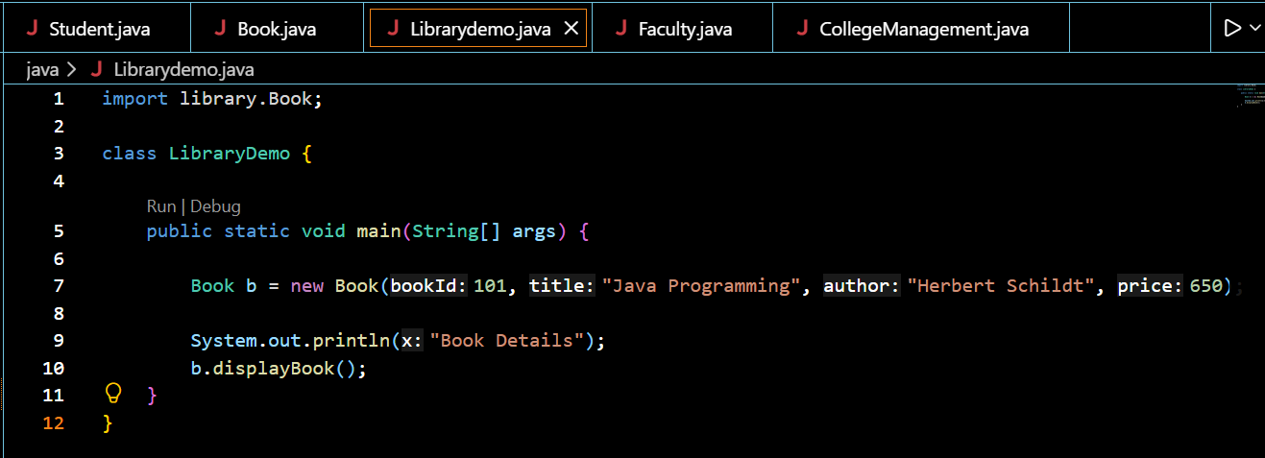

Output:
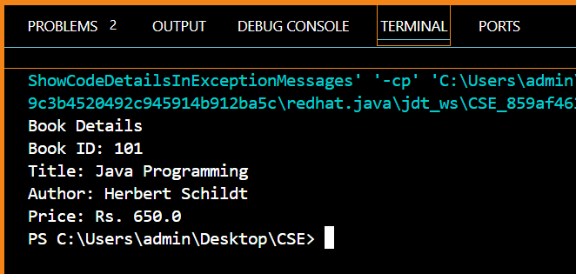

Conclusion:

This assignment helped in understanding the concept of user-defined packages in Java and how they improve code organization and reusability. It demonstrated how to create packages, import classes from different packages, and use them in a main program. The programs successfully displayed student, faculty, and book details using separate packages. Overall, the assignment enhanced the understanding of package creation and modular programming in Java.

